EXPERIMENT: WORD FREQUENCY COUNTING USING LEX/FLEX

1. AIM
To write and execute a Lex/Flex program to identify words in the input text and count the frequency of each word.

2. ALGORITHM
- Start the program.
- Include the required header files.
- Declare arrays to store words and their frequencies.
- Initialize the word count to zero.
- Read the input text using the Lex analyzer.
- Identify each word using the regular expression [a-zA-Z]+.
- Check whether the word already exists in the array.
- If the word exists, increment its frequency.
- Otherwise, store the new word and initialize its frequency to one.
- Ignore spaces, tabs, newlines, and punctuation.
- Display each word and its frequency.
- Stop the program.

3. PSEUDOCODE
START

Initialize word array and frequency array
Set n = 0

Read input text

WHILE input is available
Identify each word
Search for the word in the array

IF word is found THEN
Increase its frequency
ELSE
Store the new word
Set its frequency to 1
END IF
END WHILE

Display each word and its frequency

STOP

4. PROGRAM CODE
Filename: word_frequency.l
%{
#include <stdio.h>
#include <string.h>

char words[100][50];
int count[100];
int n = 0;
int i, found;
%}

%%
[a-zA-Z]+ {
found = 0;

for (i = 0; i < n; i++) {
if (strcmp(words[i], yytext) == 0) {
count[i]++;
found = 1;
break;
}
}

if (!found && n < 100) {
strcpy(words[n], yytext);
count[n] = 1;
n++;
}
}

[ \t\n]+ ;
. ;
%%

int main()
{
printf("Enter the input text (Ctrl+D to stop):\n");
yylex();

printf("\nWord Frequency:\n");

for (i = 0; i < n; i++) {
printf("%s : %d\n", words[i], count[i]);
}

return 0;
}

int yywrap()
{
return 1;
}

5. INPUT
hello world hello
welcome hello world

7. OUTPUT

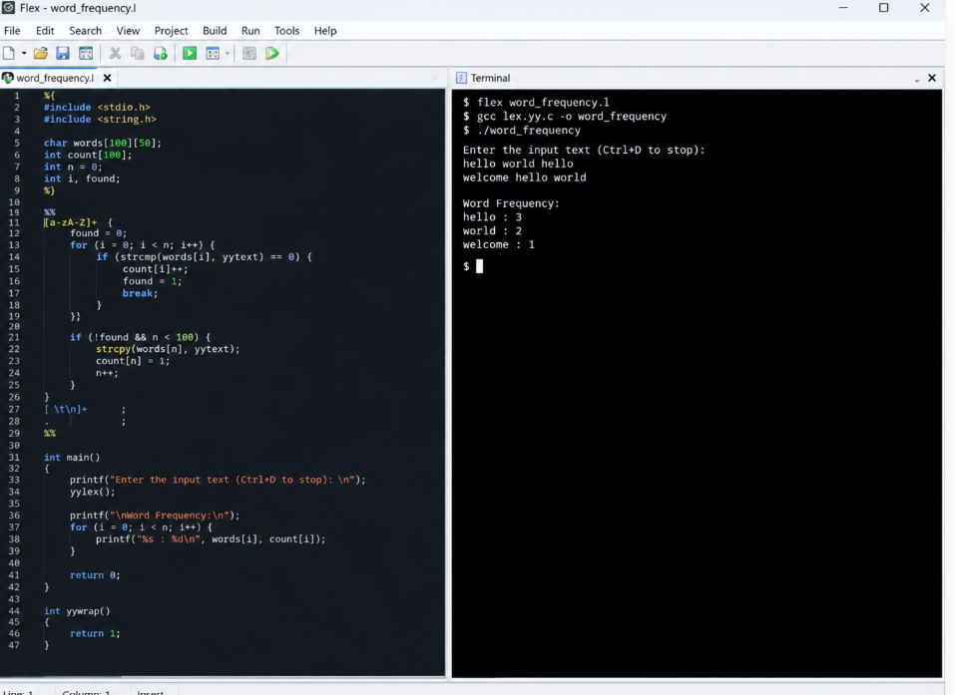

8. RESULT
Thus, the Lex/Flex program to identify words in the input text and count the frequency of each word was written and executed successfully.

